MULESOFT ANYPOINT PLATFORM
ASSIGNMENT-1
Name: Subhapreet Patro
Roll No.: 2211CS010547
Section: 1

1) Explain the concept of API LED connectivity with example.
A)
API-led connectivity is a modern integration strategy developed by MuleSoft that organizes the development and connection of APIs into a structured, reusable, and scalable approach. Rather than building point-to-point integrations, API-led connectivity enables organizations to create layers of APIs with clear purposes, allowing for easier management, faster development, and better reuse.
What is API-Led Connectivity?
API-led connectivity breaks down integration into three distinct layers of APIs:
- System APIs
- Process APIs
- Experience APIs
Each of these layers serves a different role in the architecture and helps in abstracting complexity, ensuring loose coupling, and encouraging reusability.

1. System APIs
- These APIs access core systems of record like databases, ERP systems, CRM systems, legacy software, or SaaS platforms.
- They abstract the underlying complexity of these systems by exposing only the necessary data or functionality.
- System APIs are reusable across multiple projects and consumers.
Example: A System API could connect to an SAP system to fetch product inventory details.

2. Process APIs
- These APIs combine and orchestrate data from multiple System APIs.
- They apply business logic and data transformation to the data received from various systems.
- Process APIs are independent of the source systems and the end-user applications.
Example: A Process API could combine product data from SAP and pricing information from Salesforce to create a comprehensive product catalog.

3. Experience APIs
- These APIs are designed specifically for user experiences, whether for web applications, mobile apps, or other user interfaces.
- They format and deliver data as per the needs of the specific audience or device.
- They are tailored, version-controlled, and optimized for front-end consumption.
Example: A mobile Experience API could show the product catalog in a simplified format suitable for mobile screens, while a different Experience API serves a web-based dashboard with more detailed analytics.

Why Use API-Led Connectivity?
Traditional integration approaches are often point-to-point, leading to tightly coupled, hard-to-maintain systems. API-led connectivity addresses this by promoting modular, well-structured API development that separates concerns and enables reuse.

Benefits of API-Led Connectivity
- Reusability: APIs are designed with reusability in mind, reducing redundant work across projects.
- Loose Coupling: Changes in backend systems don’t directly affect front-end applications.
- Improved Agility: New services can be created by reusing existing APIs instead of rebuilding from scratch.
- Better Governance: APIs can be monitored, secured, and managed centrally.
- Faster Development: Teams can work in parallel on different layers of the API stack.
- Standardization: Fosters a consistent way of integrating across the enterprise.

Real-World Example: Airline Booking System
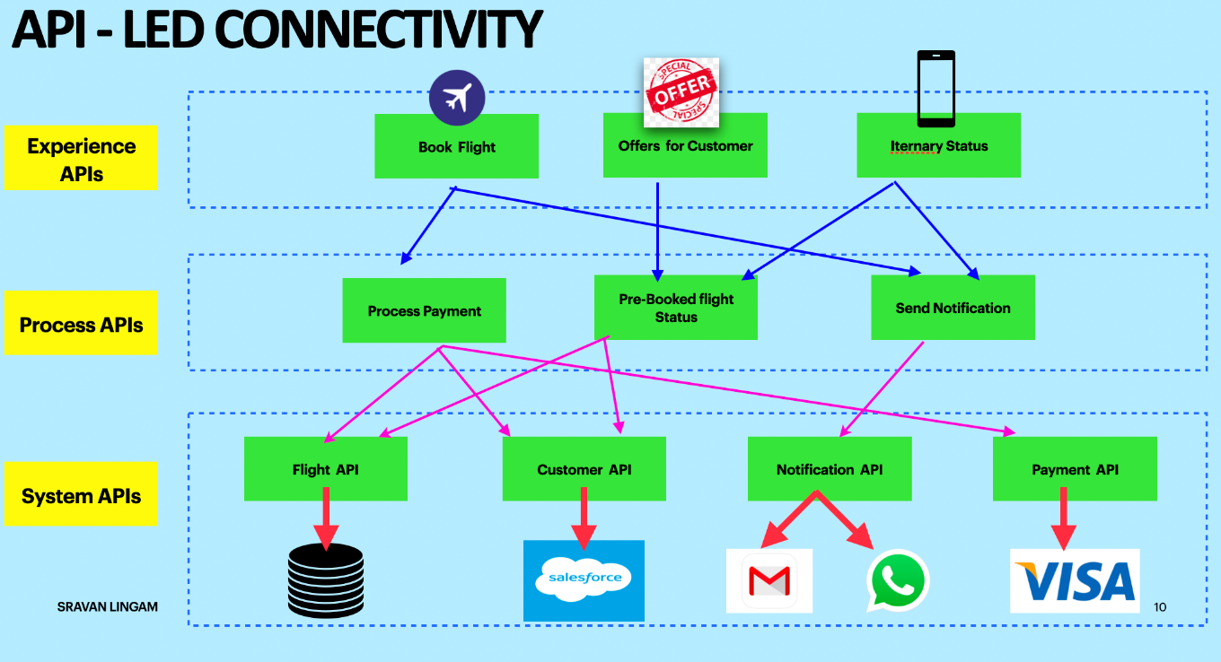
The image illustrates an airline booking system using the API-led connectivity approach. This architecture is divided into three layers: System APIs, Process APIs, and Experience APIs, each handling specific responsibilities and enabling seamless communication between different components.

1. System APIs Layer
The System APIs in this scenario connect to the backend systems and services such as databases, third-party APIs, or SaaS platforms. These APIs expose core functionalities and data sources without revealing the internal complexities.
- Flight API:
Retrieves flight details and availability from the internal flight database.
- Customer API:
Communicates with Salesforce CRM to fetch and update customer profiles and preferences.
- Notification API:
Connects with third-party messaging services like Gmail and WhatsApp to send messages and alerts.
- Payment API:
Interacts with the Visa payment gateway to process payments securely.
Each of these APIs encapsulates the logic needed to interface with a specific system and provides a standard interface to the next layer.

2. Process APIs Layer
The Process APIs orchestrate and combine data from multiple system APIs to perform meaningful business operations. These APIs are independent of user interfaces and focus purely on business logic.
- Process Payment:
Coordinates between the Payment API and Customer API to validate customer details and execute transactions.
- Pre-Booked Flight Status:
Aggregates data from the Flight API and Customer API to generate a summary of all bookings related to a specific customer.
- Send Notification:
Utilizes the Notification API to send booking confirmations, updates, and reminders to customers via email or WhatsApp.
This layer ensures all business rules are enforced and transforms data into formats needed by experience APIs.

3. Experience APIs Layer
The Experience APIs are tailored to specific user-facing channels. They provide front-end apps with exactly the data and functionality they need in the appropriate format.
- Book Flight:
Calls the Process Payment and Flight API to allow customers to search for and book flights directly from the website or mobile app.
- Offers for Customer:
Displays personalized offers and promotions by pulling data from the Customer API and business logic handled in the Process Layer.
- Itinerary Status:
Uses the Pre-Booked Flight Status and Send Notification APIs to show customers their current flight itinerary and any updates.
Each Experience API is customized for a specific channel, such as mobile apps, web dashboards, or partner portals.

How This Architecture Helps
- If the Visa payment gateway changes, only the Payment System API needs modification. The rest of the layers remain unaffected.
- The Send Notification process can be reused for multiple use cases like booking confirmations, delay alerts, or promotional messages.
- The Book Flight experience can be modified for different interfaces (e.g., mobile app vs. web portal) without altering the backend logic.

2) Write the differences between API and Web Services
A)

What is an API?
API stands for Application Programming Interface. It is a set of rules and protocols that allows different software applications to communicate with each other. APIs define how requests should be made, how data should be exchanged, and what responses to expect.
In simple terms, an API acts as a bridge between two systems. It allows one software application to access the features or data of another application, service, or platform without needing to know how it works internally.
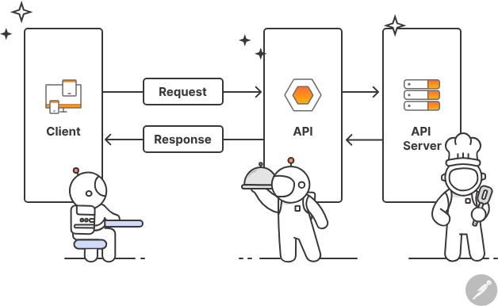
API (Application Programming Interface)

What is a Web Service?
A Web Service is a standardized way of enabling communication between two electronic devices or software systems over a network, typically the Internet. It allows applications to exchange data and perform operations using web protocols such as HTTP.
In simple terms, a web service is a type of API that is accessible over the web and allows different systems (often written in different programming languages) to interact with each other.
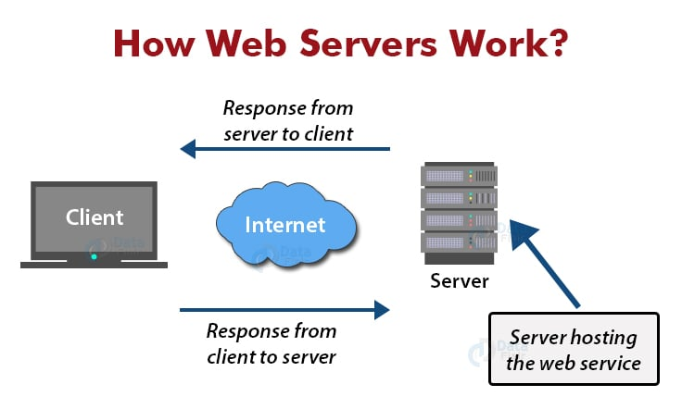

Differences between API and Web Services
S.No | Aspect | API (Application Programming Interface) | Web Services
1 | Definition | A set of rules and protocols that allow different software components to communicate. | A type of API that enables communication between two machines over a network (usually HTTP).
2 | Scope | Broader concept that includes web services, libraries, SDKs, etc. | Narrower; specifically designed for machine-to-machine communication over the web.
3 | Protocol Support | Can use any protocol like HTTP, HTTPS, FTP, SMTP, or custom protocols. | Primarily uses standard protocols like HTTP, SOAP, and sometimes REST.
4 | Data Format Support | Supports multiple formats such as JSON, XML, YAML, etc. | Traditionally uses XML (especially with SOAP-based web services).
5 | Performance | Lightweight, faster, and suitable for mobile and web applications. | Can be slower due to XML overhead and strict protocol rules.
6 | Use Cases | Used in various domains including cloud computing, mobile apps, microservices, etc. | Mostly used in enterprise-level integration, legacy systems, and service-based applications.
7 | Coupling | Offers loose coupling; easily adaptable to changes. | Tightly coupled in SOAP-based services; changes often require more updates.
8 | Flexibility and Design | Modern and flexible; can follow REST, GraphQL, or other architectural styles. | More rigid; usually follows strict contracts defined by WSDL in SOAP-based services.
9 | Accessibility | Can be private, public, or partner-based, not always exposed over the web. | Always web-based and accessible through network.
10 | Tooling and Integration | Widely supported by modern tools and frameworks across all languages and platforms. | Requires specific SOAP or REST tooling for integration.

3) What is Anypoint Platform? What are the features available in Anypoint platform?
A)
What is Anypoint Platform?
Anypoint Platform is an integrated, end-to-end platform provided by MuleSoft that allows organizations to design, develop, manage, and monitor APIs and integrations across on-premises and cloud environments. It serves as a unified solution for connecting applications, data sources, and devices, supporting both API-led connectivity and event-driven architectures.
The platform is built to simplify the integration process by enabling reuse, governance, monitoring, and accelerated development of APIs. It is widely used for digital transformation initiatives and helps companies become more agile and responsive to business needs.
Anypoint Platform includes tools for every stage of the API lifecycle—from design to deployment to monitoring—making it a full-service integration platform.

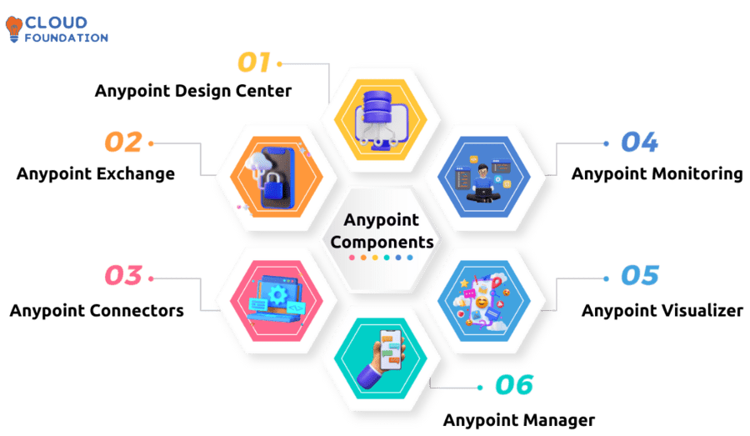
Core Capabilities of Anypoint Platform
- API Design and Development
  - Allows developers to design APIs visually or using RAML (RESTful API Modeling Language) or OpenAPI specifications.
  - Supports mocking, testing, and validating API contracts during the design phase.
- Anypoint Studio
  - A graphical, Eclipse-based development environment to build APIs and integrations using a drag-and-drop interface.
  - Built on Mule runtime engine and allows for Java-based customizations as needed.
- API Manager
  - Enables central management of APIs, including setting up policies for throttling, rate limiting, and securing APIs through OAuth2, JWT, etc.
  - Provides version control, SLA management, and analytics.
- Anypoint Exchange
  - A marketplace for APIs, connectors, templates, and other reusable assets.
  - Allows teams to publish and reuse integration components, improving productivity and consistency.
- Runtime Manager
  - A management console for deploying, monitoring, and troubleshooting Mule applications in different environments (CloudHub, on-premise, hybrid).
  - Enables visibility into system health, logs, and deployment status.
- DataWeave
  - MuleSoft’s powerful data transformation language.
  - Allows developers to map and transform data between formats like JSON, XML, CSV, Java, and more.
- Monitoring and Analytics
  - Provides real-time dashboards and analytics on API usage, latency, error rates, and system health.
  - Enables proactive alerting and troubleshooting.
- Access Management
  - Centralized identity management with role-based access control (RBAC).
  - Supports SSO, LDAP integration, and multi-factor authentication.
- Anypoint Connectors
  - Pre-built connectors for commonly used services and systems like Salesforce, SAP, Oracle, AWS, databases, HTTP, FTP, and more.
  - Reduces development time by eliminating the need to build custom integrations from scratch.
- CloudHub
  - MuleSoft’s managed cloud service for deploying APIs and integrations.
  - Offers high availability, scalability, and built-in logging and analytics.
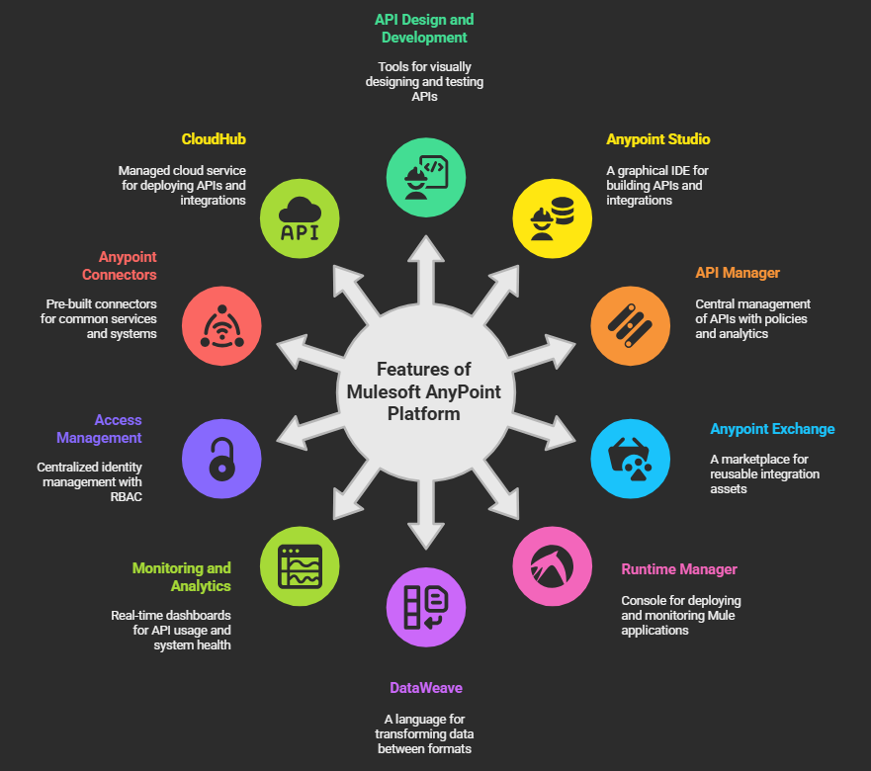
Benefits of Anypoint Platform
- Accelerated Development: Reusable assets and templates help teams deliver faster.
- Operational Visibility: Built-in monitoring and logging improve system reliability.
- Security and Governance: Central control over access, policies, and API lifecycle.
- Hybrid Deployment: Supports both on-premises and cloud environments with ease.
- Standardization and Reuse: Promotes consistent design and reuse across teams and projects.
- Agility and Scalability: Easily adapts to growing business and technical needs.

